**Android Studio**

**Manifest :**

For front end dev code .

For classes and activities declaration .

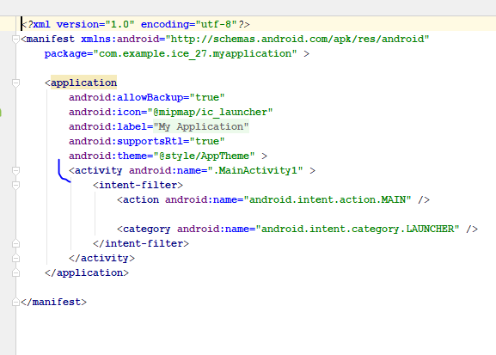

Icon theme also here ^.

Permissions also here ^ (Priveleges)

**Java :**

Main java files .

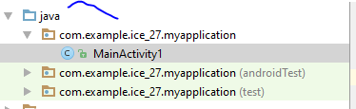

**Res :**

Drawable :

For images .

Layout :

For storing xml files . (System design)

**Mipmap :**

For logos images of the app

# Add images for every devices #

**Values :**

Colors :

Adds colors to every component.

**Gradle :**

Compiles everything and makes apk.

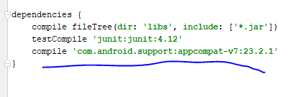

Imports library

**Text View :**

To Show output in a field type view :

Layout :

<RelativeLayout

</RelativeLayout>

#opening and closing

**Background change :**

android:background=”color_in_hexa”

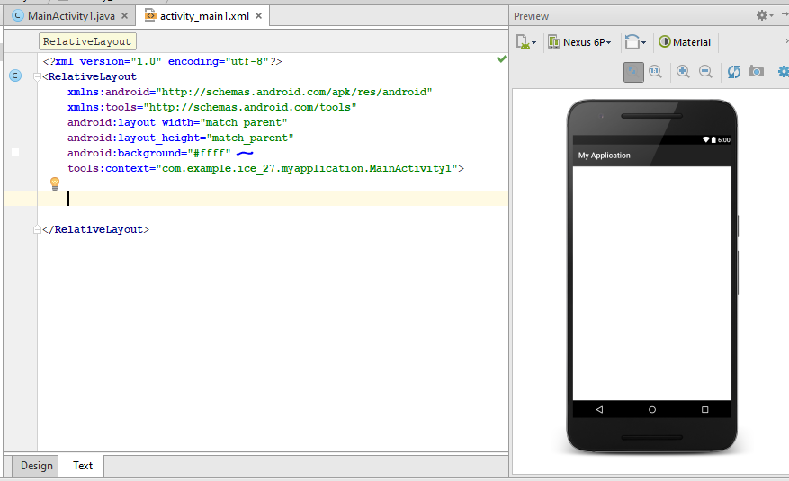

**Text View :**

android:layout_width=”wrap_content”

wrap_content : will adjust element according to their quantity.

Adjust height and width by :

android:layout_width=”50dp” or px

android:layout_height=”50dp” or px

ctrl + space for more options

**String Resources :**

Define strings in strings.xml in values

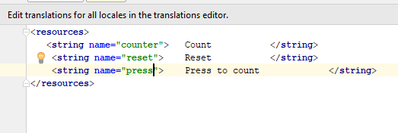

Call them with names :

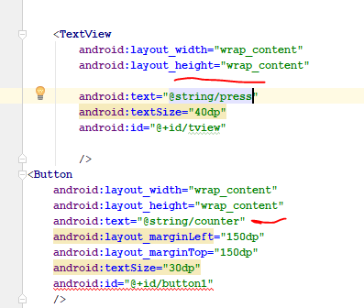

**Java file :**

**public class** MainActivity1 **extends** AppCompatActivity { #main class   
  
 @Override  
 **protected void** onCreate(Bundle savedInstanceState) {  
 **super**.onCreate(savedInstanceState);  
 setContentView(R.layout.***activity_main1***); # links to execute xml file  
 }  
}

**Linking java with xml :**

Create object of instance

TextView tv =

TextView tv = findViewbyId(R.id.”id”);

TextView tv =(TextView) findViewbyId(R.id.”id”);

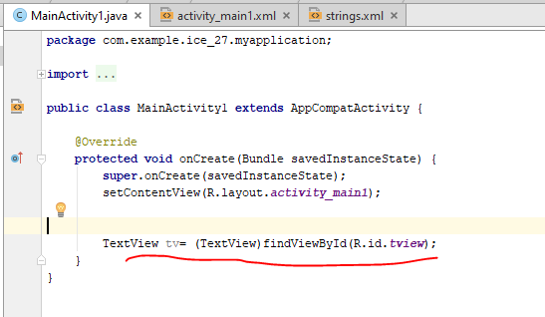

**Applying action listeners on buttons :**



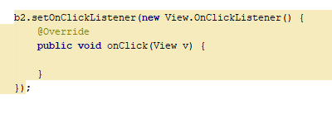

**Setting Count value :**

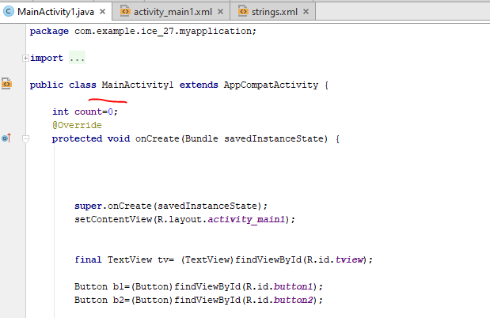

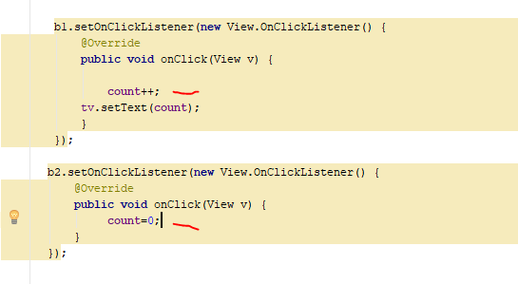

**Splash Screen :**

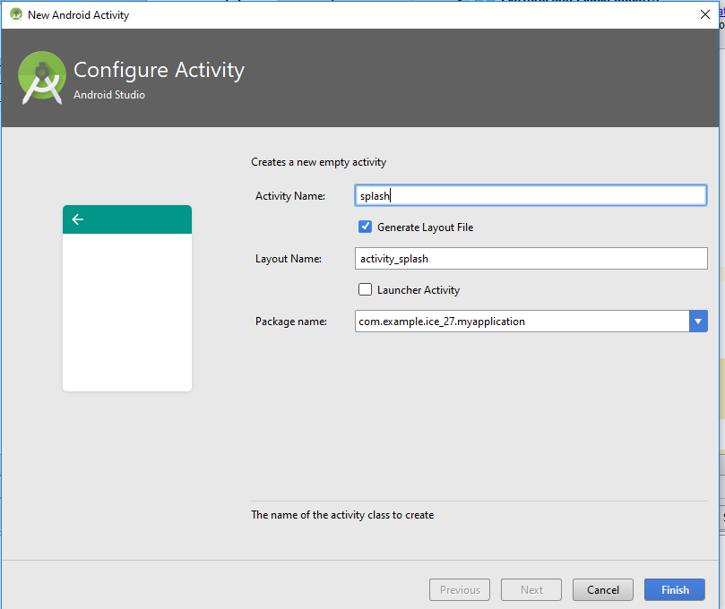

Pasting logo in drawable

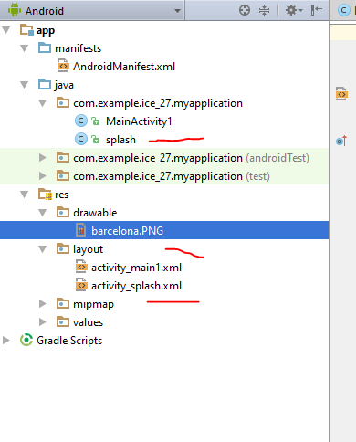

Setting logo in splash.xml

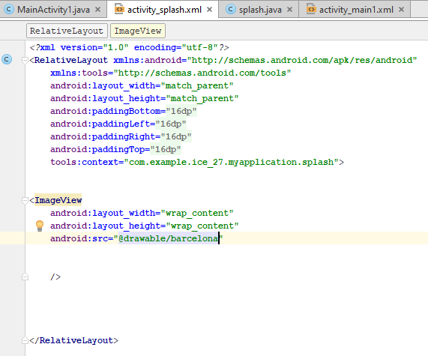

**Setting up splash screen :**

Create a thread for execution management

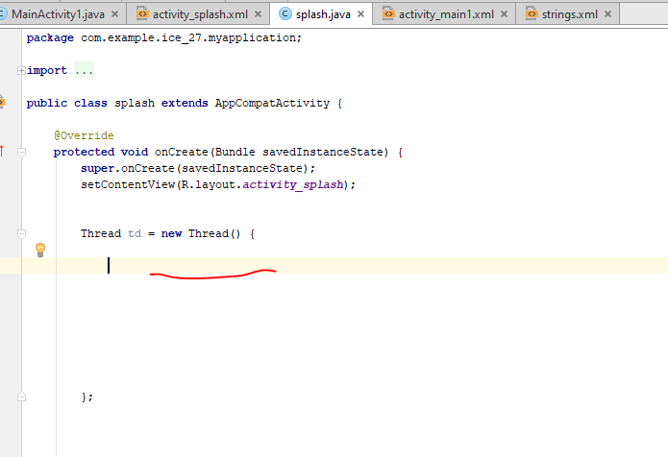

Using thread function :

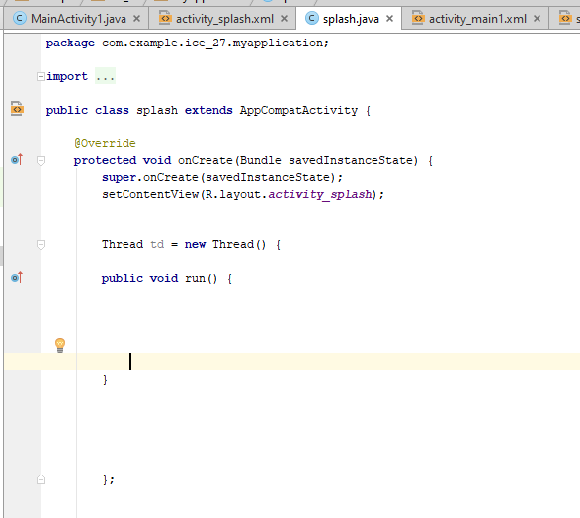

Making try catch blocks for future errors

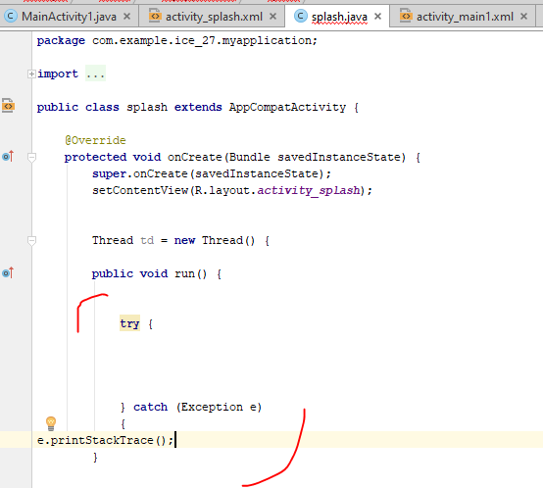

Writing sleep for screen delay which is in mili seconds .

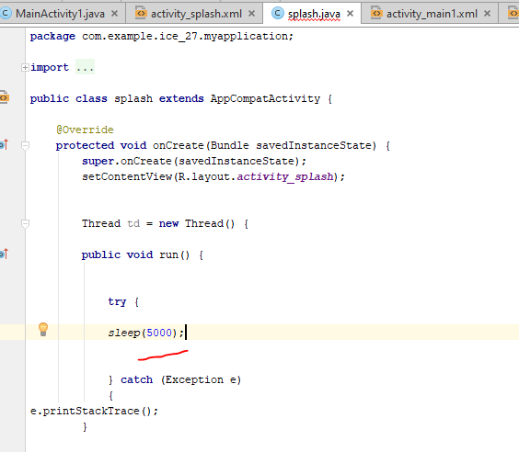

Creating intent for switching screen :

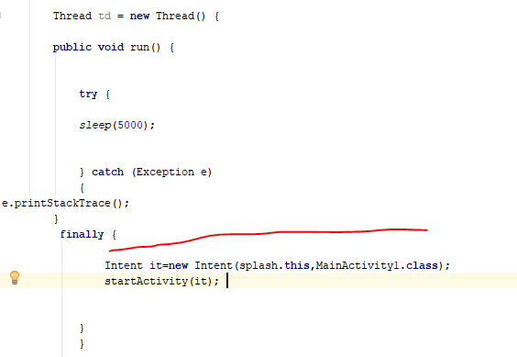

Splash.this is current screen & MainActivity1.class is target screen.

**Starting thread :**

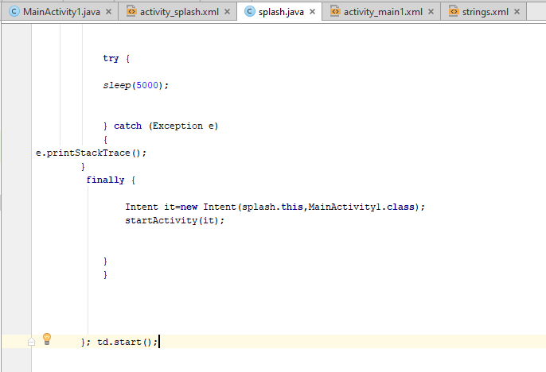

**Setting splash as page 1**

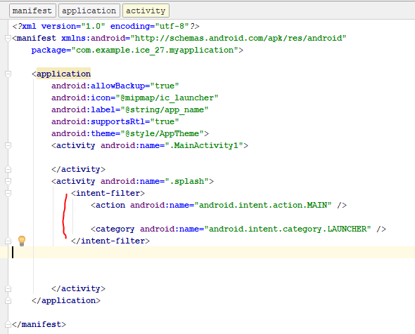

**Alternative Method :**

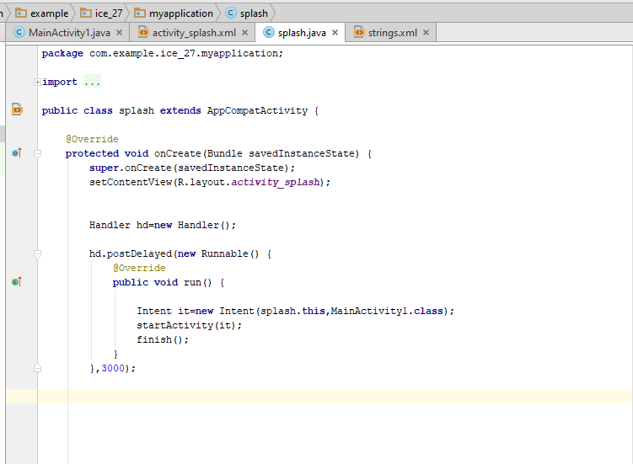

**Remove action bar :**

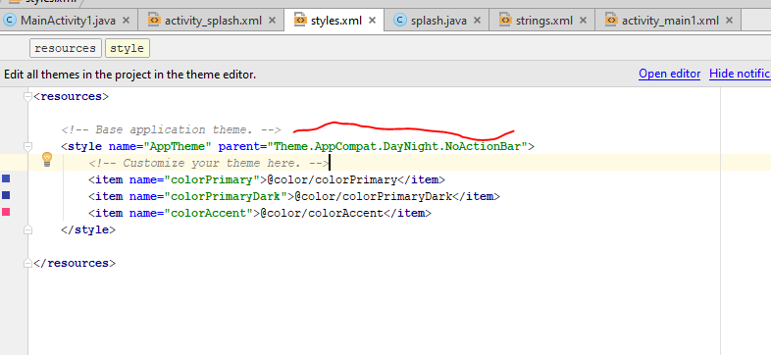

**Linear Layout :**

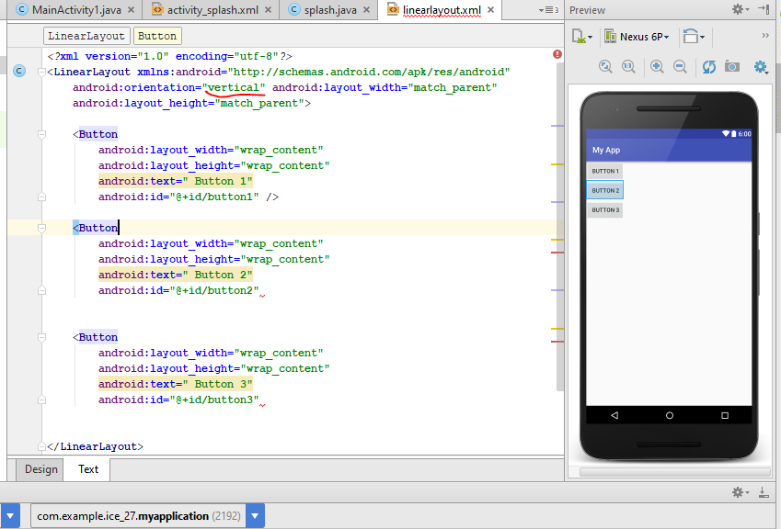

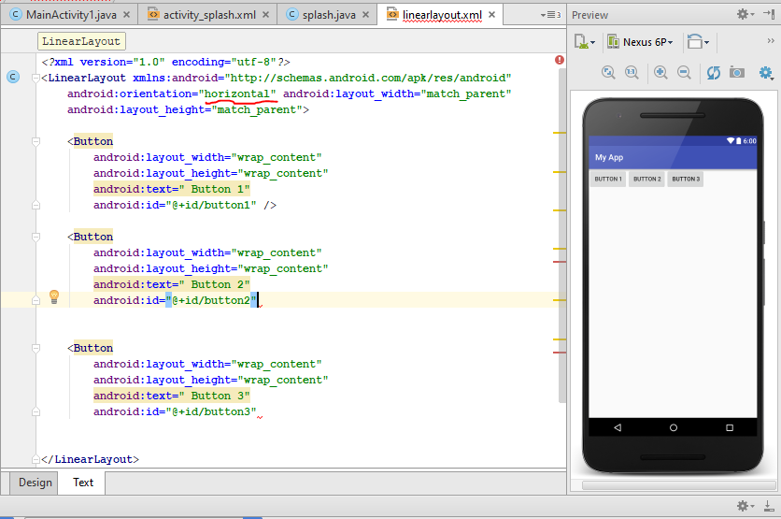

**Calculator :**

Create layout :

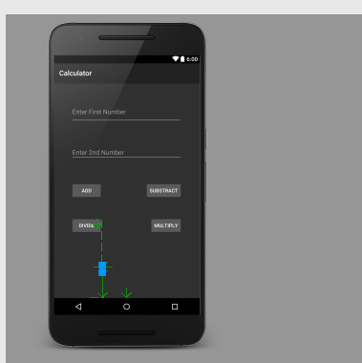

Assign Ids :

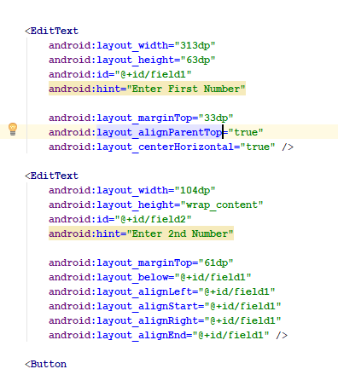

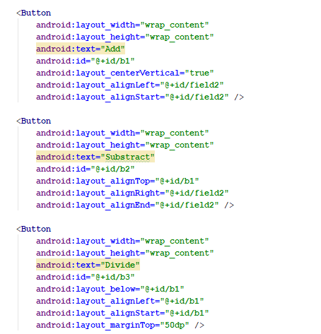

Create objects :

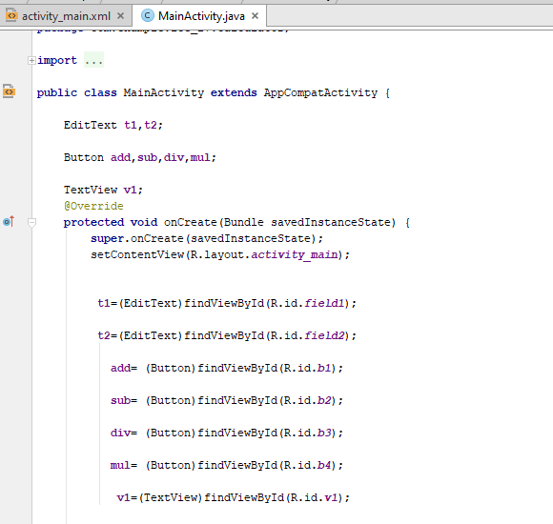

Assign action listeners :

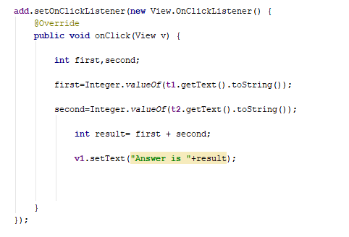

**Output :**

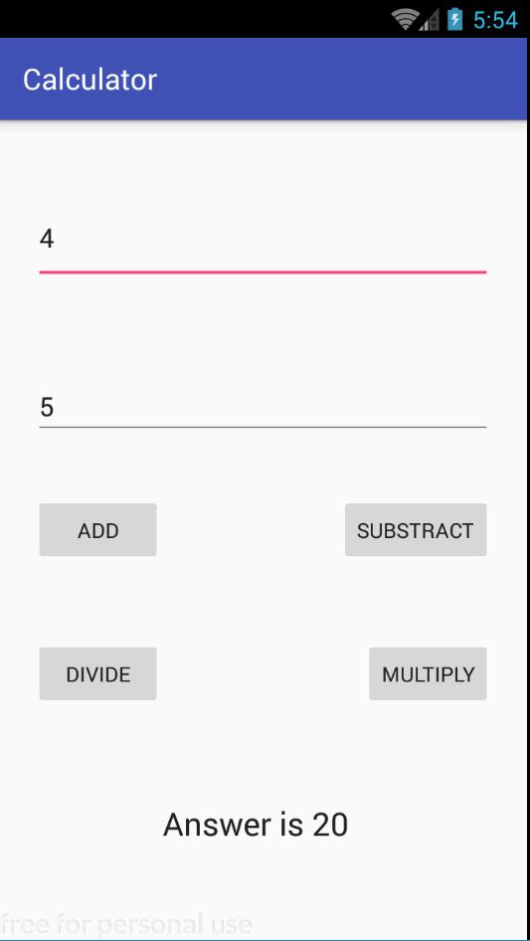

**Static Arrays :**

Go in res in strings.xml

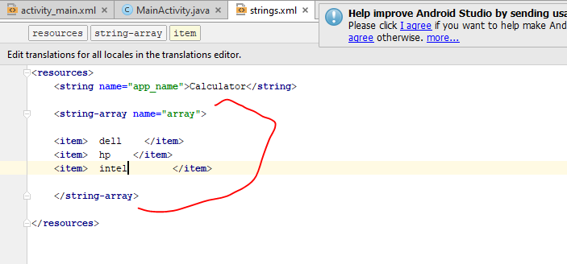

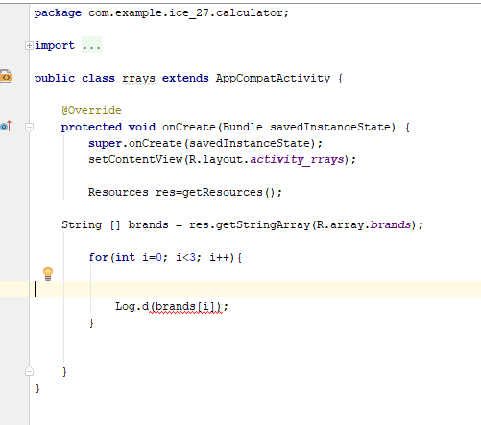

**Radio Buttons :**

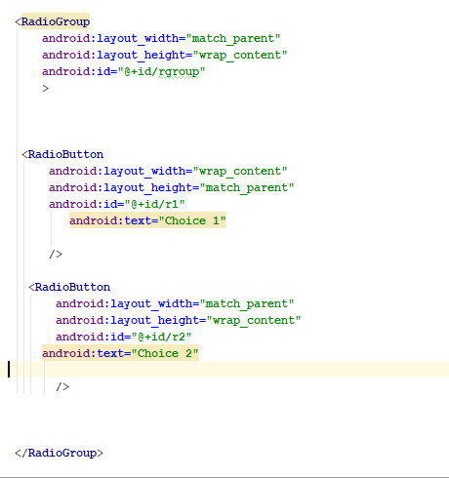

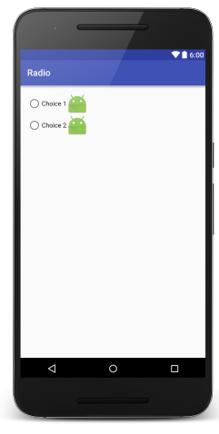

**Making object of Radio group :**

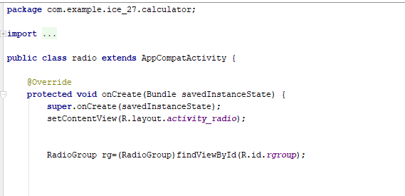

**On checked changed listener :**

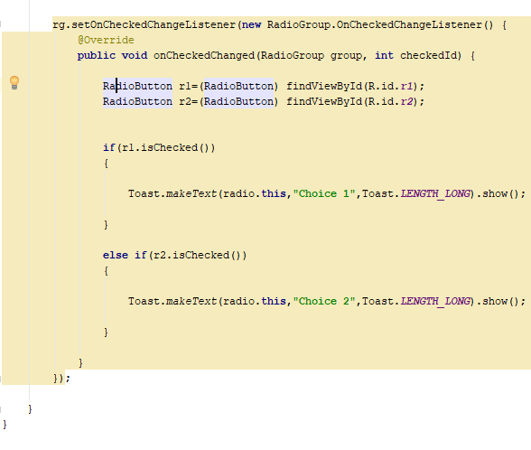

**Radio button objects are made within the on checked function .**

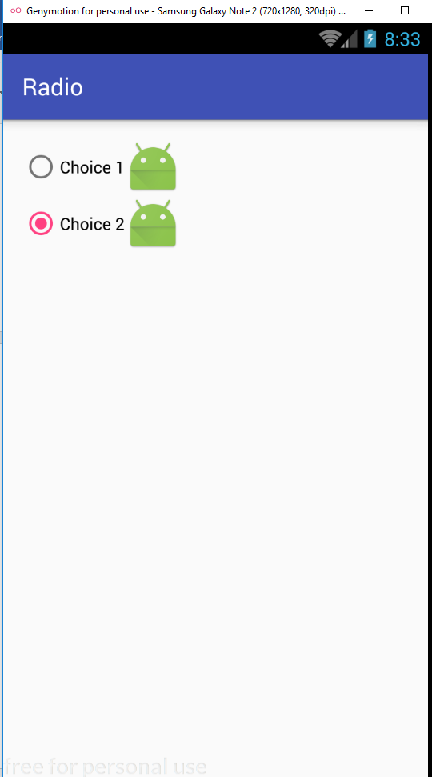

**This is toast**

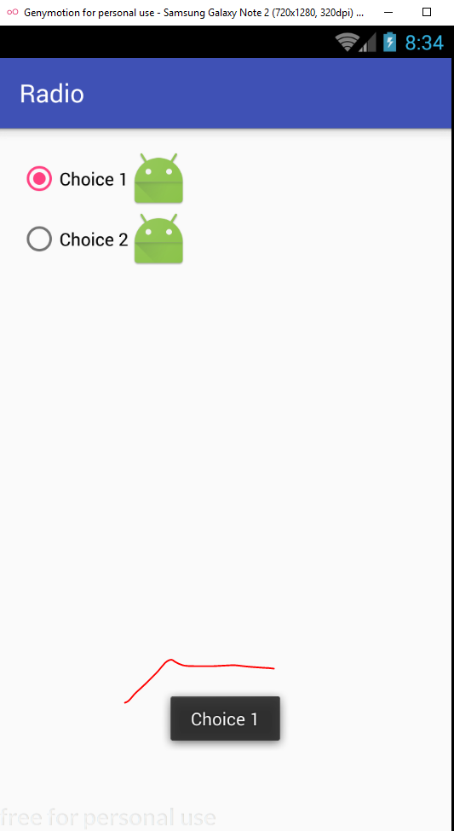

**Check Box :**

Creating view

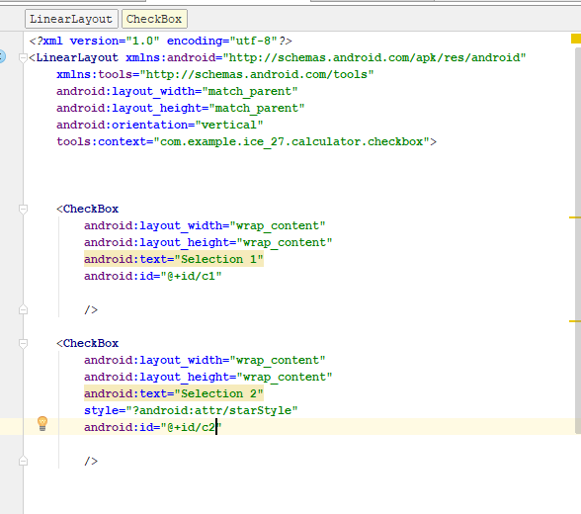

Creating objects :

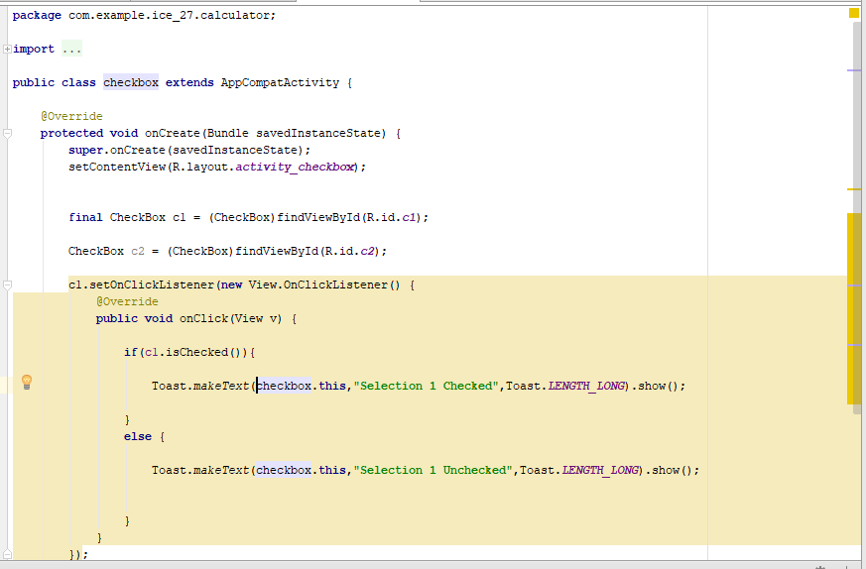

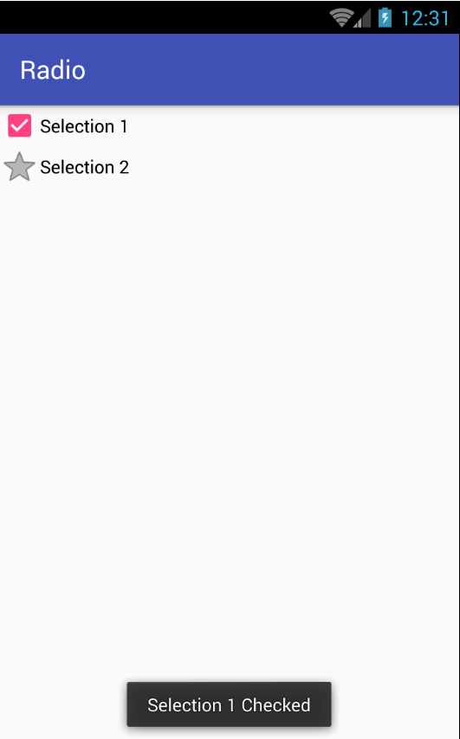

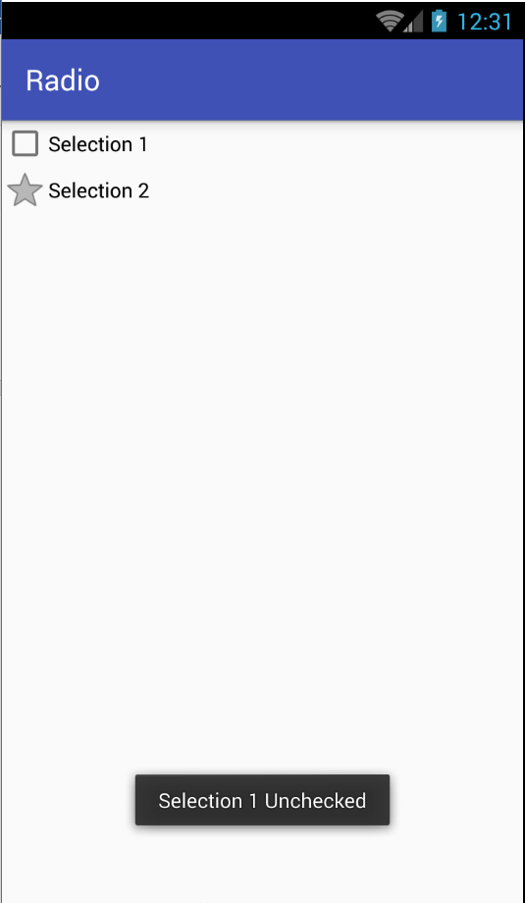

**List View :**

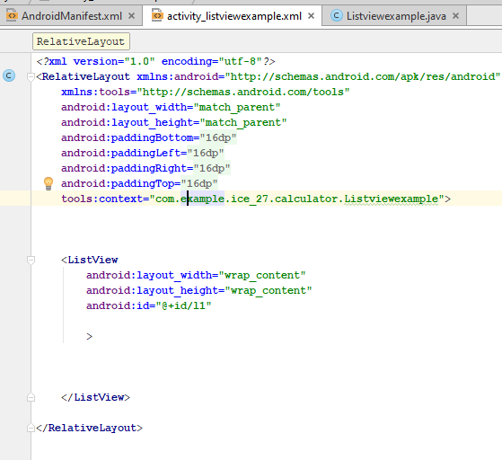

Array Adapter gets data from the array then forward the data in the list view .

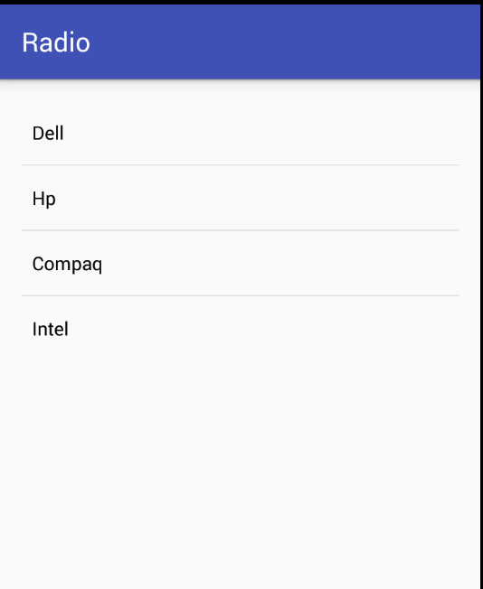

**Making List on click listeners :**

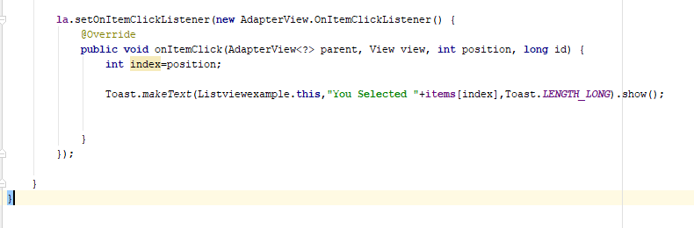

Int index=position   
will set array indexes

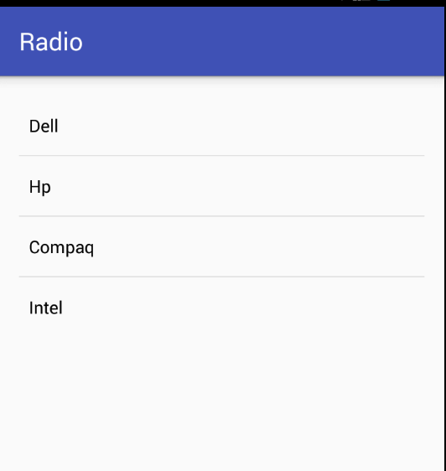

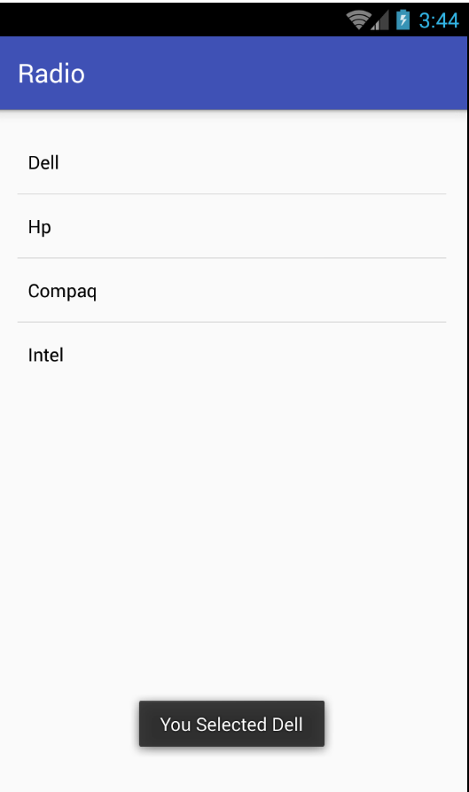

**Spinner :**

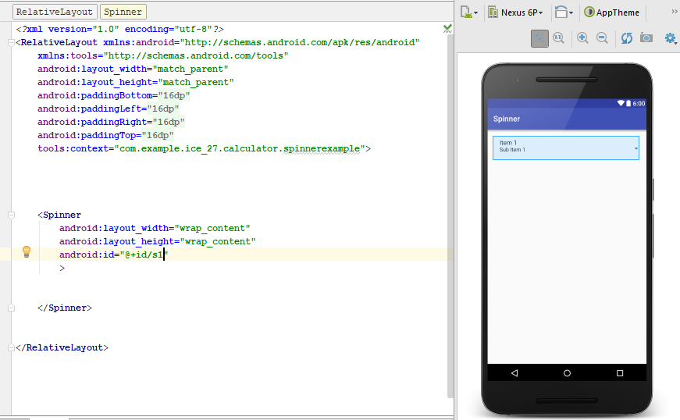

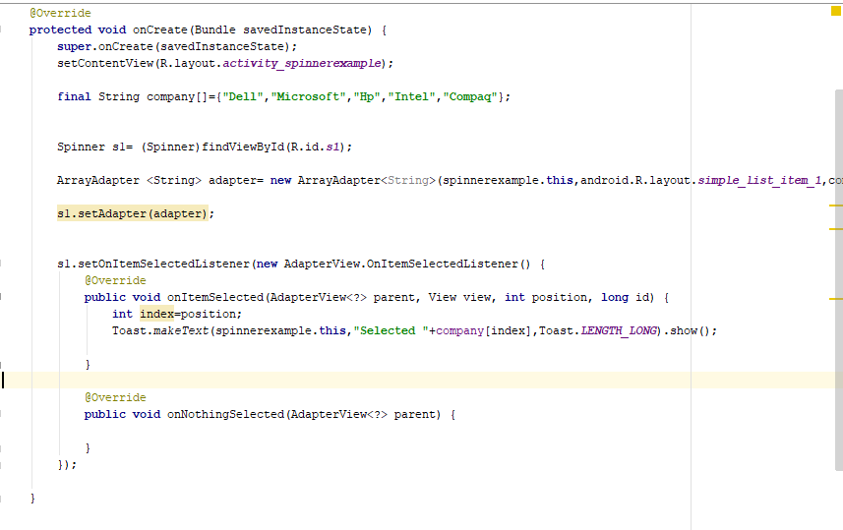

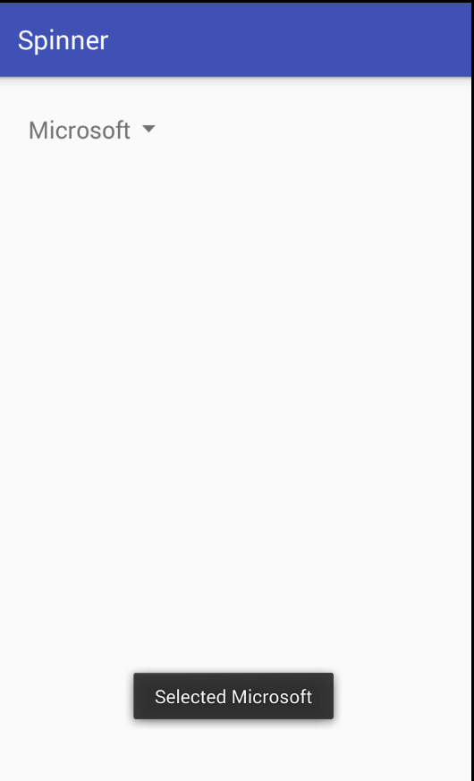

**For setting main activity :**

<intent-filter>

<action android:name="android.intent.action.MAIN" />

<category android:name="android.intent.category.LAUNCHER" />

</intent-filter>

**Intent Extra :**

Will send data from one activity to another activity.

Create page 1 xml :

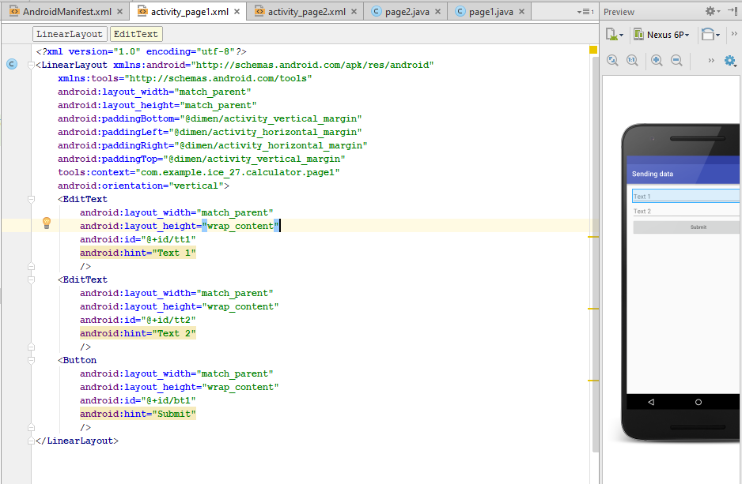

Create page 2 xml :

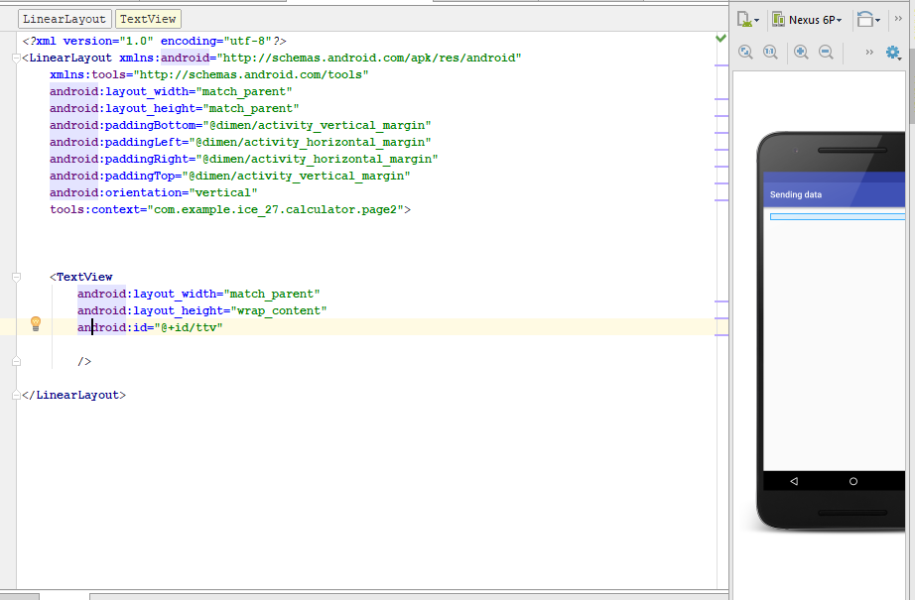

Setting page1.java

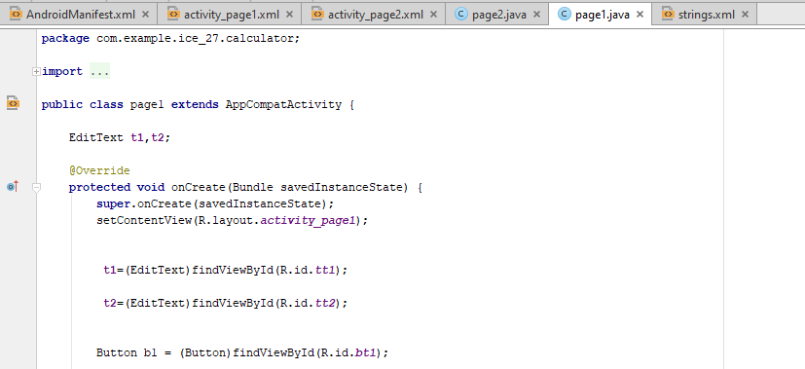

Creating intent object to send :

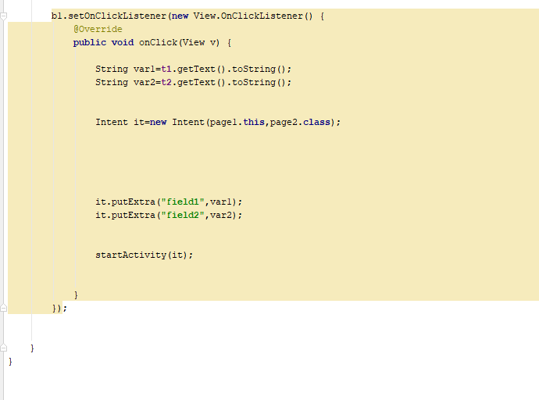

Setting up page 2.java

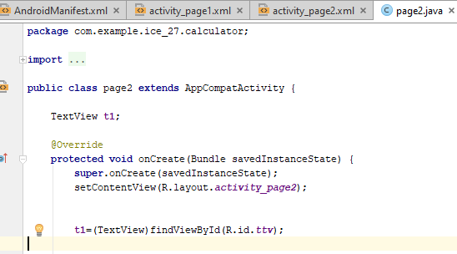

Creating intent objects to receive :

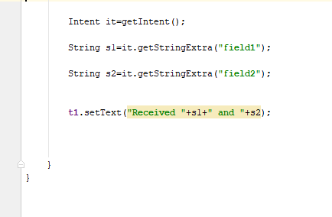

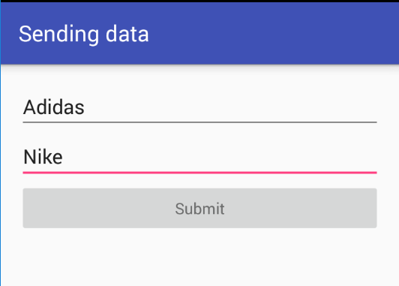

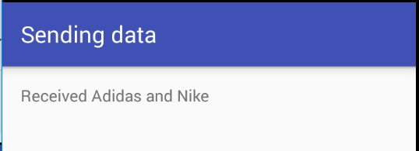

**BroadCast receiver :**

**Broadcast receiver** is an **Android** component which allows you to send or receive **Android** system or application events. ... For example, applications can register for various system events like boot complete or battery low.

Creating xml

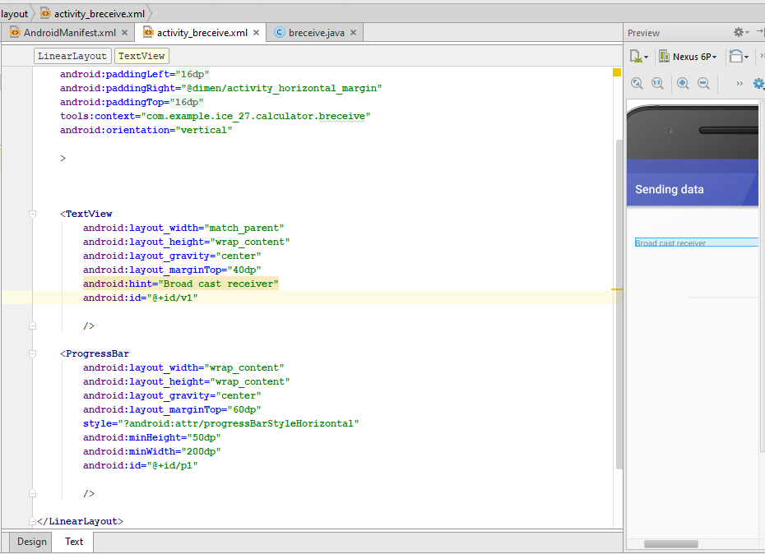

Setting up broadcast receiver :

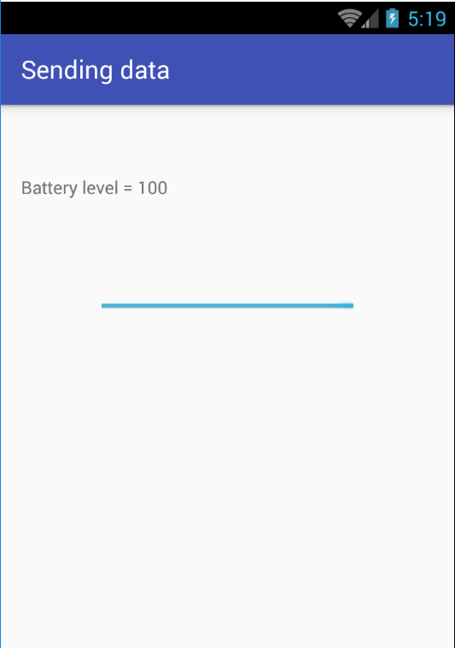

**Alert xml :**

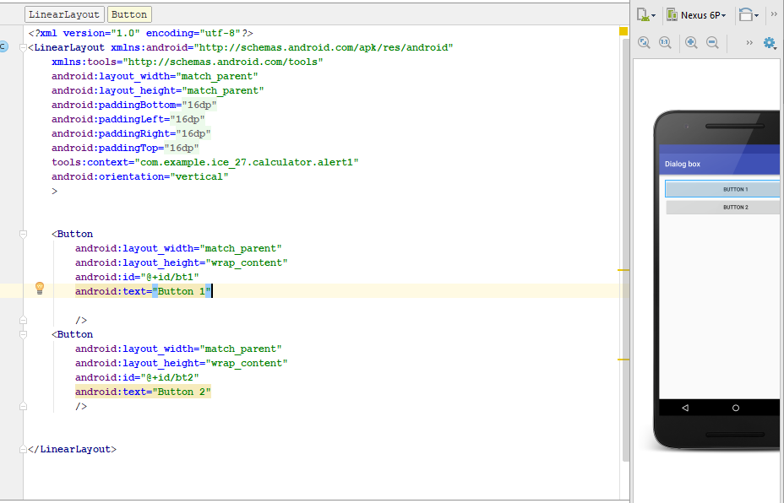

Creating objects :

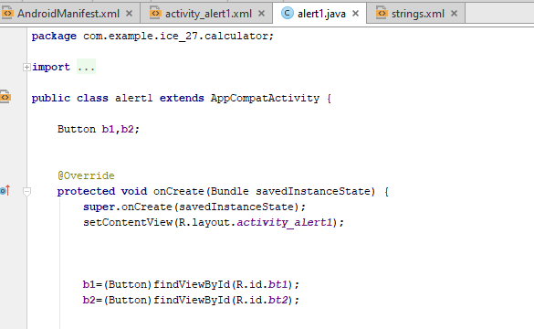

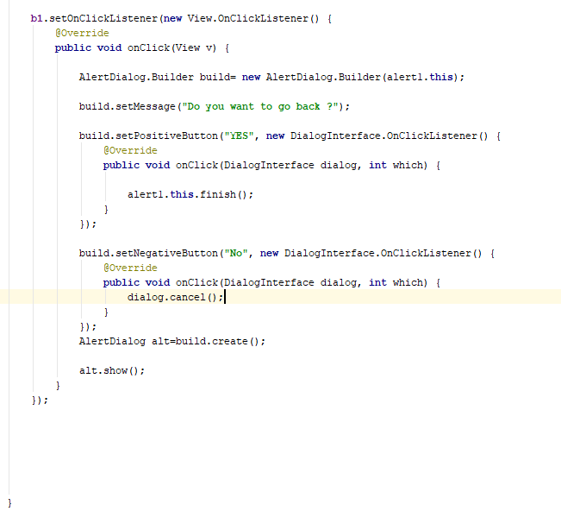

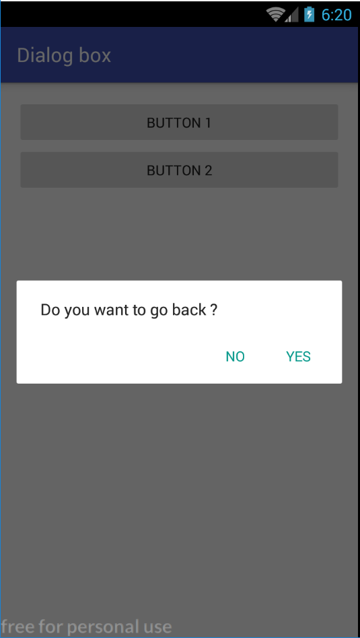

**Animation Fade in :**

Create animation resource file .

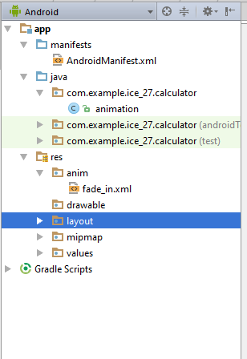

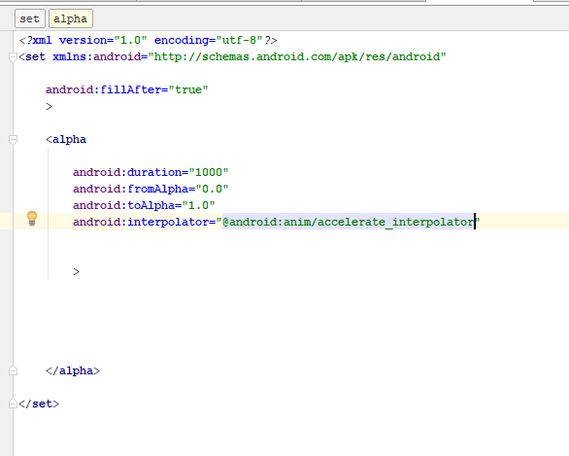

Setting up java file :

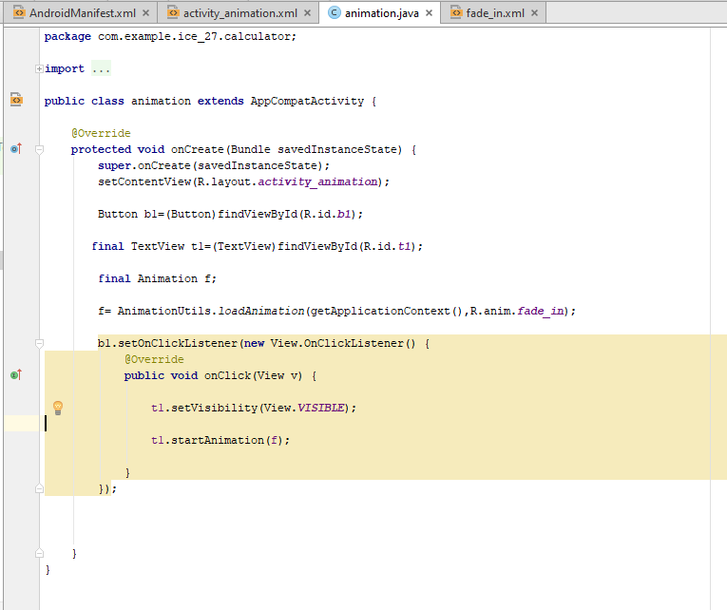

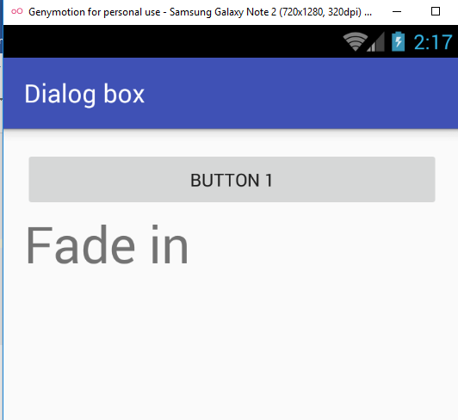

**Data BASE :**

Creating xml :

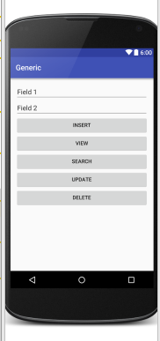

Creating sqlite.java (Has database creating tables and insert,update,delete,view functions)

**package** com.example.ice_27.calculator;  
  
**import** android.content.ContentValues;  
**import** android.content.Context;  
**import** android.database.sqlite.SQLiteOpenHelper;  
  
*/**  
 * Created by Ice-27 on 18/04/2019.  
 */***public class** SQLiteDatabase **extends** SQLiteOpenHelper {  
  
 android.database.sqlite.SQLiteDatabase **db**;  
  
  
 **private static final** String ***DATABASE_NAME***=**"Student_info"**;  
  
 **private static final int *DATABASE_VERSION***=1;  
  
  
 **private static final** String ***TABLE_STUDENT***=**"student_table"**;  
  
  
 **public static final** String ***KEY_ROW_ID***=**"ID"**;  
 **public static final** String ***KEY_FIRST_NAME***=**"FIRST_NAME"**;  
 **public static final** String ***KEY_LAST_NAME***=**"LAST_NAME"**;  
  
  
 **public** SQLiteDatabase(Context context) {  
  
  
  
  
 **super**(context, ***DATABASE_NAME***, **null** , ***DATABASE_VERSION***);  
 }  
  
 @Override  
 **public void** onCreate(android.database.sqlite.SQLiteDatabase db) {  
  
  
String CREATE_STUDENT_TABLE=**" CREATE TABLE "**+***TABLE_STUDENT***+ **" ( "**+***KEY_ROW_ID***+ **" INTEGER PRIMARY KEY AUTOINCREMENT, "**+***KEY_FIRST_NAME*** + **" TEXT, "**+***KEY_LAST_NAME***+ **" TEXT);"**;  
  
 db.execSQL(CREATE_STUDENT_TABLE);  
  
 }  
  
 @Override  
 **public void** onUpgrade(android.database.sqlite.SQLiteDatabase db, **int** oldVersion, **int** newVersion) {  
  
 db.execSQL(**"DROP TABLE IF EXISTS "**+***TABLE_STUDENT***);  
 onCreate(db);  
  
 }  
  
 **public long** insertStudent(String f1, String f2) {  
  
 **db**=**this**.getWritableDatabase();  
  
 ContentValues cv=**new** ContentValues();  
  
 cv.put(***KEY_FIRST_NAME***,f1);  
 cv.put(***KEY_LAST_NAME***,f2);  
  
 **return db**.insert(***TABLE_STUDENT***,**null**,cv);  
  
  
  
  
 }  
}

Creating main database app.java for insert

**package** com.example.ice_27.calculator;  
  
**import** android.app.Dialog;  
**import** android.support.v7.app.AppCompatActivity;  
**import** android.os.Bundle;  
**import** android.view.View;  
**import** android.widget.Button;  
**import** android.widget.EditText;  
**import** android.widget.TextView;  
  
**public class** exdatabase **extends** AppCompatActivity {  
  
 SQLiteDatabase **db**;  
  
 Button **insert**;  
  
 @Override  
 **protected void** onCreate(Bundle savedInstanceState) {  
 **super**.onCreate(savedInstanceState);  
 setContentView(R.layout.***activity_exdatabase***);  
  
  
 **final** EditText t1=(EditText)findViewById(R.id.***t1***);  
  
 **final** EditText t2=(EditText)findViewById(R.id.***t2***);  
  
 **insert**=(Button)findViewById(R.id.***insert***);  
  
 Button view=(Button)findViewById(R.id.***view***);  
  
 Button search=(Button)findViewById(R.id.***search***);  
  
 Button update=(Button)findViewById(R.id.***update***);  
  
 Button delete=(Button)findViewById(R.id.***delete***);  
  
  
 **db**=**new** SQLiteDatabase(**this**);  
  
  
 **insert**.setOnClickListener(**new** View.OnClickListener() {  
 @Override  
 **public void** onClick(View v) {  
  
 **boolean** fine = **true**;  
 **try** {  
 String f1 = t1.getText().toString();  
 String f2 = t2.getText().toString();  
  
 **db**.insertStudent(f1, f2); } **catch** (Exception e ){  
  
 fine=**false**;  
 String error=e.toString();  
 Dialog d=**new** Dialog(exdatabase.**this**);  
 d.setTitle(**"Not Inserted"**);  
 TextView tv=**new** TextView(exdatabase.**this**);  
 tv.setText(error);  
 d.setContentView(tv);  
 d.show();  
  
 } **finally** {  
 **if**(fine==**true**){  
  
 Dialog d=**new** Dialog(exdatabase.**this**);  
  
 d.setTitle(**"Inserted"**);  
 TextView tv=**new** TextView(exdatabase.**this**);  
 tv.setText(**"Success"**);  
 d.setContentView(tv);  
 d.show();  
  
 }  
 }  
  
  
 } });  
  
 }  
}

